

# Department of Computer Science and Engineering Database Management Systems — CMPS 451 Dr. Rehab Duwairi | Fall 2023 Course Team Project

|  |  |  |
| --- | --- | --- |
| ***STUDENT NAME OF SECTION L51*** | ***STUDENT QUID*** | ***STUDENT EMAIL*** |
| Fatma Ali Elbakry Elbadrawy | 201901981 | fe1901981@qu.edu.qa |
| Ferial Mohamed Zakaria Awadalla Marzouk | 201706475 | fm1706475@qu.edu.qa |
| Sara Metwally Ramadan Said | 202004852 | ss2004852@qu.edu.qa |

**Part A — Chosen Entity-Relationship Diagram (ERD) and Tools**

Chosen Diagram: Airline ERD

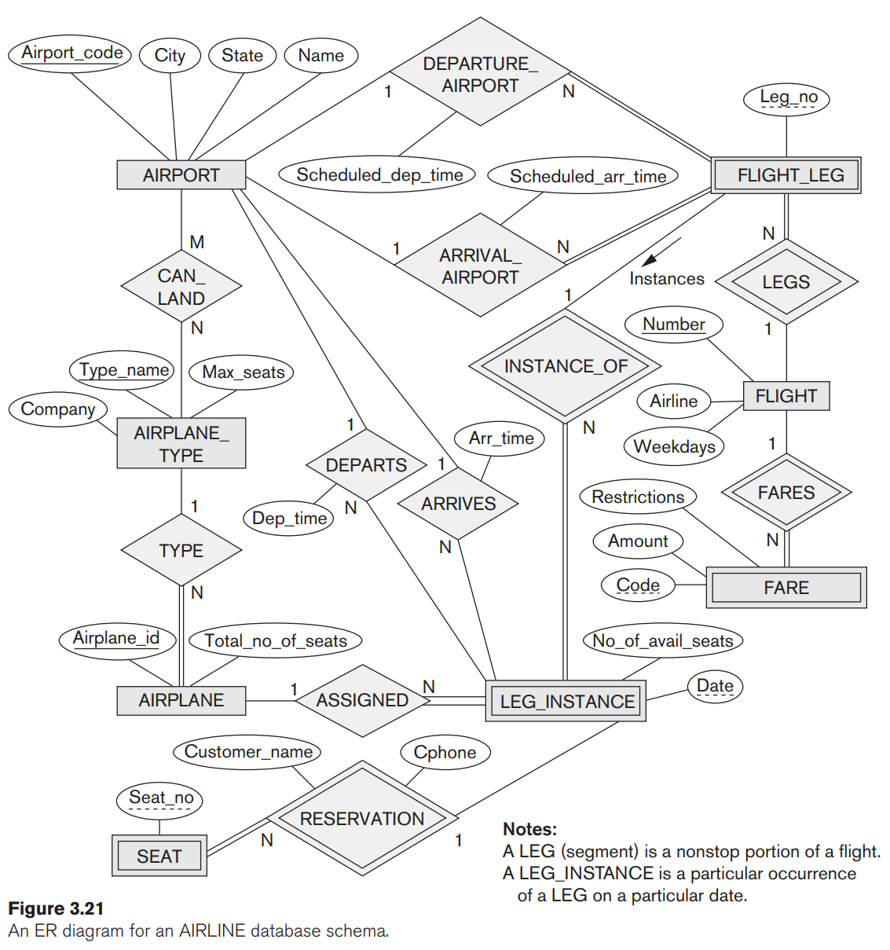  
Chosen Tools:

For the Relational Schema Creation, we chose to work with X[1]. Oracle SQL Developer, our second tool, was used to create and manage the database.

**Part B — Mapping the ER Schema to Relational Database Schema**

* First: We need to Identify all the “WEAK” and “STRONG” entities and the respective “Partial Key” and “Primary Key” of each one of the Entities.

|  |  |  |
| --- | --- | --- |
| **Entity** | **Primary/Partial Key** | **Entity Type** |
| AIRPORT | Airport_Code | STRONG |
| AIRPLANE | Airplane_ID | STRONG |
| AIRPLANE_TYPE | Type_Name | STRONG |
| FLIGHT | Number | STRONG |
| FLIGHT_LEG | Leg_NO | WEAK |
| LEG_INSTANCE | Date | WEAK |
| FARE | Code | WEAK |
| SEAT | Seat_NO | WEAK |

* Each STRONG entity will have its own relation (table), which will contain the primary key and the rest of the given attributes.
* Each WEAK entity, on the other hand, will have its own relation (table), but it will contain a combined primary key, STRONG entities’ primary key as the foreign key, alongside the given attributes. The combined primary key will be a combination of the primary key of the STRONG entity and the partial key of the WEAK entity.

The above rules of mapping of the STRONG and WEAK entities from the Entity-Relationship Diagram to a Relational Schema will give us the following different relations:

STRONG Entities:

[ADD IMAGES OF ONLY THE STRONG ENTITIES WITH UNIQUE COLOR ASSIGNED TO THEM FOR EASE OF DIFFERENTION WHILE READING]

WEAK Entities:

[ADD IMAGES OF ONLY THE STRONG ENTITIES WITH UNIQUE COLOR ASSIGNED TO THEM FOR EASE OF DIFFERENTION WHILE READING]

* Second: We need to map the relationship between entities and resolve them in the appropriate manner according to their connection and characteristics:

[TO BE CONTINUED – WORK IN PROGRESS]

**Part C: SQL DDL statements to Create and Populate the Relations**

1. A Legend is going to be provided explaing the usage and meaning of each sybmol used by our Relational Schema designing tool.